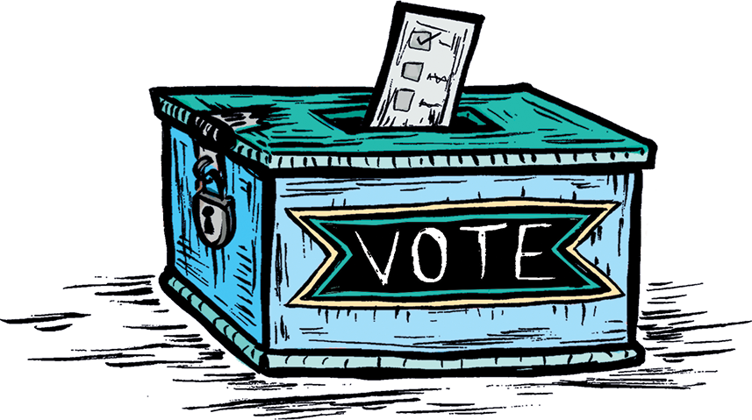

March On! Open Ended Discussion Questions:

1. What is voting?

2. Why do people vote?

3. Do you think voting is important? Why or why not?

4. Have you ever been to vote with your parent or another adult? What did you notice?

5. What is a peaceful protest?

6. What are some examples of peaceful protests?

7. Have you seen or heard about any protests happening right now? What do you think they are about?

8. Do you think peaceful protests are useful? Why or why not?

9. Have you ever attended a march or another peaceful protest? What did you notice?

10. What are some other ways that people can make change in the world around them?

11. If you see something that you don’t agree with in your community, what are some ways that you can work to fix it?

12. Are there things you want to change in your community now? What would you change and why?

Common Core Aligned Questions by Grade:

Pre-Kindergarten - Kindergarten

1. Who are the main characters in the story?

2. Where does the story take place?

3. What is the main problem in the story?

4. How do the women in the story try to solve the problem?

5. What do you notice about how the women in the book look?

6. Choose any page in the story. How does the picture help you understand what is happening on the page?

Grades 1 - 2

1. Who are the main characters in the story? What problem are they trying to solve?

2. Where and when do the events in the story take place?

3. What are some ways that the women in the story try to solve the problem?

4. What is the central message of the story?

5. Why do the women in the story think it is important to vote?

6. Look at the pictures in the story. What do they tell you about the characters?

7. Do you notice that there are women of different races in the book? What have you learned about racism?

8. How do the women feel in the story? What words or phrases in the story help you understand their feelings?

Grades 3 - 4

1. What is the central message of the story? Use at least two details from the story to answer the question.

2. What is the problem in the story? Use at least two details from the story to answer the question.

3. Which sentence best explains why the women in the story think voting is important?

4. What actions do the women in the story take to solve the problem? What is the result of these actions?

5. Do you think voting is important? Why or why not?

6. How would you have solved the problem in the story?

7. What do you think about the fact that even after the law changed, women of color still had a hard time voting? Do you see things around you now that are unfair?

8. What do the illustrations tell you about the characters in the story?

www.MarchOnNY.com

